

**SWE ProjectAndThesis**

**Submitted By:**

Md. Rezwan Ibnee Mohsin

ID: 151 – 35 – 982

This **Project** report has been submitted in fulfillment of the requirements for the Degree of Bachelor of Science in Software Engineering.

**Department of Software Engineering**

**Daffodil International University**

**Spring – 2019**

**Copyright 2019 ©Daffodil International University**

# APPROVAL

This **Project** Report submitted by **Md. Rezwan Ibnee Mohsin, ID 151 – 35 – 982** to the Department of Software Engineering, Daffodil International University has been accepted as satisfactory for the partial fulfillment of the requirements for the degree of Bachelor of Science in Software Engineering and approval as to its style and contents.

**BOARD OF EXAMINERS**

|  |  |
| --- | --- |
| **---------------------------------------------------------**  **Dr. Touhid Bhuiyan Professor and Head**  Department of Software Engineering  Faculty of Science and Information Technology Daffodil International University | **Chairman** |
| **---------------------------------------------------------**  **Dr. Md. Asraf Ali Associate Professor**  Department of Software Engineering  Faculty of Science and Information Technology Daffodil International University | **Internal Examiner 1** |
| **---------------------------------------------------------**  **Ms. Manan Binth Taj Noor Lecturer**  Department of Software Engineering  Faculty of Science and Information Technology Daffodil International University | **Internal Examiner 2** |
| **---------------------------------------------------------**  **Dr. Md. Nasim Akhtar Professor**  Department of Computer Science Engineering  Dhaka University of Engineering & Technology, Gazipur | **External Examiner** |

**DECLARATION**

I hereby declare that, this **Project** Report has been done by me under the supervision of **Md. Anwar Hossen**, Senior lecturer, Department of Software Engineering, Faculty of Science and Information Technology, Daffodil International University. I also declare that neither this report nor any part of this report has been submitted elsewhere for award of any degree.

**Submitted By:**

**……………………**

**Md. Rezwan Ibnee Mohsin**

ID: 151 – 35 – 982

Department of Software Engineering

Faculty of Science and Information Technology

Daffodil International University

**Certified By:**

**……………………**

**Md. Anwar Hossen**

Senior lecturer

Department of Software Engineering

Faculty of Science and Information Technology

Daffodil Interna



**SWE ProjectAndThesis**

**Submitted By:**

Md. Rezwan Ibnee Mohsin

ID: 151 – 35 – 982

This **Project** report has been submitted in fulfillment of the requirements for the Degree of Bachelor of Science in Software Engineering.

**Department of Software Engineering**

**Daffodil International University**

**Spring – 2019**

**Copyright 2019 ©Daffodil International University**

# APPROVAL

This **Project** Report submitted by **Md. Rezwan Ibnee Mohsin, ID 151 – 35 – 982** to the Department of Software Engineering, Daffodil International University has been accepted as satisfactory for the partial fulfillment of the requirements for the degree of Bachelor of Science in Software Engineering and approval as to its style and contents.

**BOARD OF EXAMINERS**

|  |  |
| --- | --- |
| **---------------------------------------------------------**  **Dr. Touhid Bhuiyan Professor and Head**  Department of Software Engineering  Faculty of Science and Information Technology Daffodil International University | **Chairman** |
| **---------------------------------------------------------**  **Dr. Md. Asraf Ali Associate Professor**  Department of Software Engineering  Faculty of Science and Information Technology Daffodil International University | **Internal Examiner 1** |
| **---------------------------------------------------------**  **Ms. Manan Binth Taj Noor Lecturer**  Department of Software Engineering  Faculty of Science and Information Technology Daffodil International University | **Internal Examiner 2** |
| **---------------------------------------------------------**  **Dr. Md. Nasim Akhtar Professor**  Department of Computer Science Engineering  Dhaka University of Engineering & Technology, Gazipur | **External Examiner** |

**DECLARATION**

I hereby declare that, this **Project** Report has been done by me under the supervision of **Md. Anwar Hossen**, Senior lecturer, Department of Software Engineering, Faculty of Science and Information Technology, Daffodil International University. I also declare that neither this report nor any part of this report has been submitted elsewhere for award of any degree.

**Submitted By:**

**……………………**

**Md. Rezwan Ibnee Mohsin**

ID: 151 – 35 – 982

Department of Software Engineering

Faculty of Science and Information Technology

Daffodil International University

**Certified By:**

**……………………**

**Md. Anwar Hossen**

Senior lecturer

Department of Software Engineering

Faculty of Science and Information Technology

Daffodil International University

**Acknowledgement**

First of all, I am grateful to the Almighty Allah for making me eligible to complete this project. Then I would like to thank my supervisor **Md. Anwar Hossen, Senior Lecturer**, Department Of Software Engineering. I am extremely grateful and indebted to him for his expert, sincere and valuable guidance and encouragement extended to me.

Beside my supervisor, I would like to express my sincere thanks to **Dr. Touhid Bhuiyan**, Professor and Head of Software Engineering Department for his constant encouragement.

I would like to thank them who were helped in my project by their very important suggestions without their passionate participation and input; the project could not be successfully conducted. I take this opportunity to record my sincere thanks to all the faculty members of the Department of Software Engineering for their help and encouragement.

Last but not least, I would like to thank our parents, for their unconditional support, love and without this we would not have come this far.

**Executive Summary**

SWE ProjectAndThesis is an android based application by which the students of SWE department of DIU will be able to know the details about the information of the previous project or thesis courses of SWE department. Teachers can create virtual classroom. A student will be able to join the virtual classroom and can find their project or thesis related documents.

They can search for projects by name or by programming languages. Students will find the assignments which have been called by the teachers. Admin will add courses here. Also he or she can add semesters. Then he or she can add previous projects here. Admin can update courses and

update previous projects as well. The students will be able to submit assignments here and they can upload one or multiple attachments here.

The objectives of this project are to manage project and thesis related course of software engineering department more efficiently and to handle the project or thesis related course tasks easily. It will help students to find information about previous courses and to find the project related documents more efficiently and to submit their project or thesis related assignments more easily where as it will help the teachers to manage the courses more efficiently than ever.

**Table of Contents**

**Chapter I****1**

Introduction 1

1.1. Project Overview 1

1.2. Project Purpose 1

1.2.1. Background 1

1.2.2. Benefits & Beneficiaries 2

Benefits: 2

Beneficiaries: 2

1.2.3. Goals 2

1.3. Stakeholders 2

1.4. Proposed System Model 3

1.4.1. Agile-Model 3

1.5. Project Schedule 4

1.5.1. Gantt Chart 4

1.5.2. HR Planning for Development Phase 5

1.5.3. Release Plan 5

**Chapter II****6**

Software Requirement Specification 6

2.1. Functional Requirements 6

2.2. Data Requirements 7

2.3. Performance Requirements 7

2.3.1. Speed and Latency Requirements 7

2.3.2. Precision or Accuracy Requirements 7

2.3.3. Capacity Requirements 8

2.4. Dependability Requirements 8

2.4.1. Reliability Requirements 8

2.4.2. Availability Requirements 8

2.4.3. Robustness or Fault-Tolerance Requirements 9

2.5. Maintainability and Supportability Requirements 9

2.5.1. Maintenance Requirements 9

2.5.2. Supportability Requirements 9

2.5.3. Adaptability Requirements 9

2.6. Security Requirements 10

2.6.1. Access Requirements 10

2.6.2. Integrity Requirements 10

2.6.3. Privacy Requirements 10

2.7. Usability and Human-Interaction Requirements 10

2.8. Look and Feel Requirements 11

2.8.1. Appearance Requirements 11

2.8.1. Style Requirements 11

**Chapter III****12**

System Analysis 12

3.1. Use Case Diagram 12

3.2. Use Case Description 13

3.2.1. Register 13

3.2.2. Check email 13

3.2.2. Submit verification code 14

3.2.3. Login 14

3.2.4. Add product to tracking 17

3.3. Activity Diagram 18

3.3.1. Activity Diagram for Customer 18

3.3.2. Activity for Admin 19

3.3.3. Activity for Staff 20

**Chapter IV****21**

System Design Specification 21

4.1 Sequence Diagram 21

4.1.1. Order product, Track Product 21

4.1.2. Manage Orders, Add Tracking 22

4.1.3. Manage Orders 23

4.2. Dataflow Diagram 24

4.2.1. DFD Level-0 24

4.2.2. DFD Level-1 25

4.3. ERD Diagram 26

**Chapter V****27**

User Interface and Manuals 27

5.1. User Interface 27

5.1.1. Home Page 27

5.1.2. Cart 28

5.1.3. Sign in Page 29

5.1.4. Order Tracking Page 30

5.1.5. Order Tracking Page 31

5.1.6. Admin Area (Add Product) 32

5.1.7. GPS Tracking 33

**Chapter VI****34**

Development Tools & Technologies 34

6.1. User Interface Technologies 34

6.2. Implementation Technologies 34

6.2.1. NodeJS (11.3.0) 34

6.2.2. NPM (5.7.1) 34

6.2.3. ExpressJS (4.16.4) 34

6.2.4. MongoDB (4) 34

6.2.5. Google Map JavaScript API 35

6.3. Platform & Environment 35

6.3.1. Hardware 35

6.3.2. Tools 35

6.3.3. Version Control 35

**Chapter VII****36**

System Testing 36

7.1. Introduction 36

7.2. Test Plan Strategy 36

7.3. Test Case 36

7.3.1. Test Case of Login 37

7.3.2. Test Case of Sign Up 37

7.3.2. Test Case of Cart 38

7.3.3. Test Case of Location Tracking 39

7.4. Features yet not tested 40

**Chapter VIII****41**

Project Summary 41

8.1. GitHub Link 41

8.2. Limitations 41

8.3. Obstacle & Achievements 41

8.4. Conclusion 41

8.5. Future Work 42

**Key of Terms****43**

**References****44**

**List of Figure**

Figure 1 : Agile-Model 3

Figure 2: Gantt chart 4

Figure 3: Use Case Diagram 12

Figure 4: Activity for customer 18

Figure 5: Activity diagram for admin and staff 19

Figure 6: Activity for staff 20

Figure 7: Sequence 1 21

Figure 8: Sequence 2 22

Figure 9: Sequence 3 23

Figure 10: DFD Level-0 24

Figure 11: DFD Level-1 25

Figure 12: ERD 26

Figure 13: Home Page 27

Figure 14: Cart 28

Figure 15: Sign in page 29

Figure 16: Order Tracking Page 30

Figure 17: Order Tracking Page 2 31

Figure 18: Add Product (admin) 32

Figure 19: GPS Tracking 33

**List of Table**

Table 1: Functional Requirements 6

Table 2: Data requirements 7

Table 3 Speed and Latency Requirements 7

Table 4: Precision or Accuracy Requirements 7

Table 5: Capacity Requirements 8

Table 6: Reliability Requirements 8

Table 7: Availability Requirements 8

Table 8: Robustness or Fault-Tolerance Requirements 9

Table 9: Maintenance Requirements 9

Table 10: Supportability Requirements 9

Table 11: Adaptability Requirements 9

Table 12: Access Requirements 10

Table 13: Integrity Requirements 10

Table 14: Privacy Requirements 10

Table 15: Appearance Requirements 11

Table 16: Style Requirements 11

Table 17: Order Product 13

Table 18: Track Orders 14

Table 19: Manage Products 15

Table 20: Manage Orders 16

Table 21: Add tracking 17

Table 22: Test case of login 37

Table 23: Test case of signup 38

Table 24: Test case of cart 39

Table 25: Test case of location 40

Table 26: Features yet not tested 40

**Chapter I**

**Introduction**

**1.1. Project Overview**

SWE ProjectAndThesis is an android based application. SWE ProjectAndThesis involves managing project or thesis related courses as effectively as possible. It involves managing previous project or thesis records. It also involves showing the stats of the previously completed projects, notifying the students about the Project assignments. It also involves Handling the project course related tasks more efficiently, showing the list of projects which are completed or ongoing Providing search facilities to search for particular projects by project name or languages or framework used. This project also involves creating virtual classroom by the teachers. The teachers can call assignments here and the students will be able to submit assignments as attachments and they will be able to find the project or thesis related documents here and they can see the previous project stats and graphs about the percentage of programming language used here.

The special feature of this application is showing the graph and statistics about the programming languages used in projects or thesis. Here student will also find the search functionality for searching previous projects by name or by programming languages. It will help the student to find the project or thesis related documents more efficiently.

**1.2. Project Purpose**

**1.2.1. Background**

Managing the project or thesis related courses manually is really a difficult task. Moreover, finding necessary documents about thesis or projects manually takes a lot of hard work in our department. So I thought if there were an application where students will be able to know about the previously completed projects and where they will find project related documents and teachers can create virtual classroom and call assignments there and the students will submit assignments and see the stats and graphs about previous project or thesis then that can help to manage the project or thesis course more efficiently.

© 2019 Daffodil International University 1

**1.2.2. Benefits & Beneficiaries**

**Benefits:**

* Managing the project or thesis related course more efficiently
* Helps to find the project related documents easily
* Provides virtual classroom to manage project related assignments
* Saves time and reduces workload of project or thesis related courses

**Beneficiaries:**

* Students of SWE department
* Teachers of SWE department

**1.2.3. Goals**

Every project or application has some goals. SWE ProjectAndThesis application has goals too. The goals of SWE ProjectAndThesis are:

* To meet a solution to manage the project or thesis related courses efficiently
* To help the students to know about previously completed projects or thesis
* To provide a virtual platform from where the project or thesis assignments will be managed nicely
* To help the students to find the project related documents

The main purpose of this project is to replace manual project or thesis courses management and to save time and reduce workload of the courses from teachers as well as students.

**1.3. Stakeholders**

A stakeholder is a party or group of people who has an interest in a company and can either affect or be affected by the business. The primary stakeholders of SWE ProjectAndThesis are:

* **Students of the SWE department of DIU**
* **Teachers of the SWE department of DIU**
* **Software engineering department**

© 2019 Daffodil International University 2

**1.4. Proposed System Model**

Proposed system model is a simplified representation of a software process. Each model represents a process of a project from specific perspectives. SWE ProjectAndThesis has also a system model.

**1.4.1. Agile-Model**

The proposed system model of SWE ProjectAndThesis is agile model which is an incremental process of software development. Each iteration lasts one to three weeks on average. Engineering actions are carried out by cross functional teams. In software development the term “agile” means the ability to respond to changes-changes from requirements, technology and people.

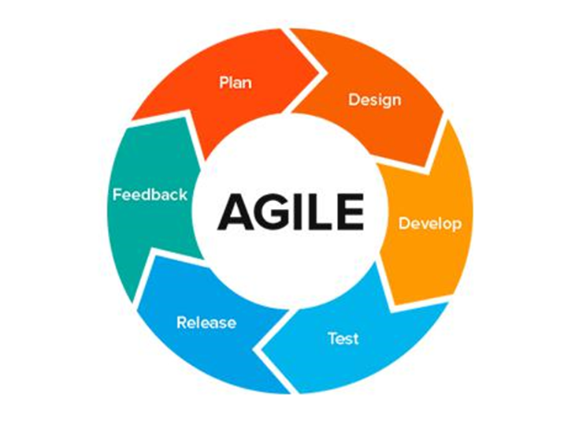

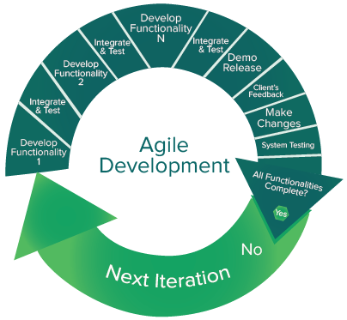

**Figure 1 : Agile-Model**

© 2019 Daffodil International University 3

**1.5. Project Schedule**

In project management, a schedule is a listing of project‟s milestones, activities, and deliverables, usually with intended start and finish dates. A schedule is commonly used in the project planning and project portfolio management parts of project management.

**1.5.1. Gantt Chart**

|  |  |  |  |  |  |  |  |  |  |  |  |  |
| --- | --- | --- | --- | --- | --- | --- | --- | --- | --- | --- | --- | --- |
|  |  |  |  |  |  |  |  |  |  |  |  |  |

|  |  |  |  |  |  |  |  |  |  |  |  |  |  |  |  |
| --- | --- | --- | --- | --- | --- | --- | --- | --- | --- | --- | --- | --- | --- | --- | --- |
| |  | | --- | | **Weeks** |   **Works** | 1 | 2 | 3 | 4 | 5 | 6 | 7 | 8 | 9 | 10 | 11 | 12 | 13 | 14 |
| **Analysis Phase** |  |  |  |  |  |  |  |  |  |  |  |  |  |  |
| **Feasibility Study** |  |  |  |  |  |  |  |  |  |  |  |  |  |  |
| **Project proposal** |  |  |  |  |  |  |  |  |  |  |  |  |  |  |
| **Project UI** |  |  |  |  |  |  |  |  |  |  |  |  |  |  |
| **Mid**-**term defense** |  |  |  |  |  |  |  |  |  |  |  |  |  |  |
| **Implementation of the project** |  |  |  |  |  |  |  |  |  |  |  |  |  |  |
| **Testing** |  |  |  |  |  |  |  |  |  |  |  |  |  |  |
| **Document of the project** |  |  |  |  |  |  |  |  |  |  |  |  |  |  |
| **Final defense** |  |  |  |  |  |  |  |  |  |  |  |  |  |  |

**Figure 2: Gantt chart**

© 2019 Daffodil International University 4

**1.5.2. Planning for Development Phase**

1. Planning for project
2. Project analysis
3. Requirement gathering
   * Brainstorming
   * Interview
   * Observation
   * Analysis
4. Design
   * System design
   * Database design
   * User interface design
5. Development
   * Student Module
   * Teacher Module
   * Others
6. Testing
   * Test plan
   * Test Case
   * Test Execution

**1.5.3. Release Plan**

Release 1: Version 1.0.0 on 29/04/2019

Release 2: Version 2.0.0 on 04/05/2019

© 2019 Daffodil International University 5

**Chapter II**

**Software Requirement Specification**

**2.1. Functional Requirements**

**Table 1: Functional Requirements**

|  |  |  |
| --- | --- | --- |
| SRS NO | Requirement name | Priority |
| #01 | Create an account | High |
| #02 | Login | High |
| #03 | Adding Courses as Admin | High |
| #04 | Assign Courses to Teachers | High |
| #05 | Creating Teachers profile | High |
| #06 | Call assignments as Teacher | High |
| #07 | Controlling content of dashboard | High |
| #08 | Creating virtual classroom | High |
| #09 | Approving Student virtual classroom joining request | High |
| #10 | Showing ongoing or completed project list | High |
| #11 | Adding search functionalities to project list | High |
| #12 | Showing Previous project stats | High |
| #13 | Student’s assignment submission as attachments | High |
| #14 | Showing the student list who submitted assignments | High |
| #15 | Adding search functionalities to project list | High |
| #16 | Providing project related documents | Medium |
| #17 | Showing previous project graphs | High |

© 2019 Daffodil International University 6

**2.2. Data Requirements**

**Table 2: Data requirements**

|  |  |  |
| --- | --- | --- |
| No | Description | Priority |
|  |  |  |
| #01 | Student or teacher have to submit the verification code accurately | High |
|  | to register into the application. |  |
|  |  |  |
| #02 | Students have to insert the login credentials accurately. | High |
|  |  |  |
| #03 | Teachers have to insert accurate login credential to login to the system. | High |
|  |  |  |
| #04 | Teachers have to select course name and section to add his courses info. | High |
|  |  |  |
| #05 | Teachers must select semester, course, section to create virtual classroom. | High |
|  |  |  |

**2.3. Performance Requirements**

**2.3.1. Speed and Latency Requirements**

**Table 3 Speed and Latency Requirements**

|  |  |  |
| --- | --- | --- |
| No | Description | Priority |
|  |  |  |
| #01 | The email with the verification code should reach as quickly as possible. | Medium |
|  |  |  |
| #02 | When the project will be searched by alphabets it should show the | Medium |
|  | searched data list in runtime. |  |
|  |  |  |
| #03 | The Application must have a high speed of manipulation data and | Medium |
|  | reply to the user request. |  |
|  |  |  |

**2.3.2. Precision or Accuracy Requirements**

**Table 4: Precision or Accuracy Requirements**

|  |  |  |
| --- | --- | --- |
| No | Description | Priority |
|  |  |  |
| #01 | The input data should be validate when Student, teacher or admin | Medium |
|  | provide data to the system. |  |
|  |  |  |
| #02 | All data should be placed accurately where the data is associated. | Medium |
|  |  |  |

© 2019 Daffodil International University 7

**2.3.3. Capacity Requirements**

**Table 5: Capacity Requirements**

|  |  |  |
| --- | --- | --- |
| No | Description | Priority |
|  |  |  |
| #01 | The application must able to load all data from server. | Medium |
|  |  |  |
| #02 | The Mysql database size must be able to store the | Low |
|  | Application data. |  |
|  |  |  |
| #03 | System should support 1k user at the beginning version | Low |
|  |  |  |
| #04 | System should support 1000 request per second. | Low |
|  |  |  |

**2.4. Dependability Requirements**

**2.4.1. Reliability Requirements**

**Table 6: Reliability Requirements**

|  |  |  |
| --- | --- | --- |
| No | Description | Priority |
|  |  |  |
| #01 | Confidential data’s must have to be encrypted. | Medium |
|  |  |  |
| #02 | The data should be collected from users by permission and by accepting | Low |
|  | privacy policy. |  |
|  |  |  |
| #03 | Users data cannot be used by anyone for any other purpose except | Low |
|  | system needs. |  |
|  |  |  |

**2.4.2. Availability Requirements**

**Table 7: Availability Requirements**

|  |  |  |
| --- | --- | --- |
| No | Description | Priority |
|  |  |  |
| #01 | Application should work 24 hours a day | Medium |
|  |  |  |
| #02 | Application should provide the desired data to the user in time | Low |
|  |  |  |

© 2019 Daffodil International University 8

**2.4.3. Robustness or Fault-Tolerance Requirements**

**Table 8: Robustness or Fault-Tolerance Requirements**

|  |  |  |
| --- | --- | --- |
| No | Description | Priority |
|  |  |  |
| #01 | Application should not be crashed more than one time in a day. | Low |
|  |  |  |
| #02 | Application must be responsive to all kind of smartphone screen size. | Low |
|  |  |  |

**2.5. Maintainability and Supportability Requirements**

**2.5.1. Maintenance Requirements**

**Table 9: Maintenance Requirements**

|  |  |  |
| --- | --- | --- |
| No | Description | Priority |
|  |  |  |
| #01 | The Application maintenance should be as quick as possible. | Low |
|  |  |  |

**2.5.2. Supportability Requirements**

**Table 10: Supportability Requirements**

|  |  |  |
| --- | --- | --- |
| No | Description | Priority |
|  |  |  |
| #01 | The Application must support latest android studio version. | Medium |
|  |  |  |
| #02 | Should support all the screen size. | Low |
|  |  |  |

**2.5.3. Adaptability Requirements**

**Table 11: Adaptability Requirements**

|  |  |  |
| --- | --- | --- |
| No | Description | Priority |
|  |  |  |
| #01 | The Application must adapt all upgraded version and time. | Low |
|  |  |  |
| #02 | New version of Application should support latest gradles. | Low |
|  |  |  |

© 2019 Daffodil International University 9

**2.6. Security Requirements**

**2.6.1. Access Requirements**

**Table 12: Access Requirements**

|  |  |  |
| --- | --- | --- |
| No | Description | Priority |
|  |  |  |
| #01 | The access of all users have to be limited with their use case boundaries. | Low |
|  |  |  |
| #02 | Users like students, teachers need to be authorized first to access data. | Medium |
|  |  |  |
| #03 | User’s boundaries should be within the application. | Low |
|  |  |  |

**2.6.2. Integrity Requirements**

**Table 13: Integrity Requirements**

|  |  |  |
| --- | --- | --- |
| No | Description | Priority |
|  |  |  |
| #01 | Authorized users can add or delete data only with their respective | Low |
|  | accessibility. |  |
|  |  |  |
| #02 | Only admin can add, update, delete course and previous projects. | Medium |
|  |  |  |

**2.6.3. Privacy Requirements**

**Table 14: Privacy Requirements**

|  |  |  |
| --- | --- | --- |
| No | Description | Priority |
|  |  |  |
| #01 | Users data must not be visible publicly. | High |
|  |  |  |
| #02 | User data should not contain any private issues | Medium |
|  |  |  |
| #03 | All of the confidential data should be encrypted. | Medium |
|  |  |  |

**2.7. Usability and Human-Interaction Requirements**

No visible usability and Human-Interaction requirements.

© 2019 Daffodil International University 10

**2.8. Look and Feel Requirements**

**2.8.1. Appearance Requirements**

**Table 15: Appearance Requirements**

|  |  |  |
| --- | --- | --- |
| No | Description | Priority |
|  |  |  |
| #01 | The user interface must be as attractive as possible. | High |
|  |  |  |
| #02 | The user interface must be user friendly. | Medium |
|  |  |  |
| #03 | The user interface must be as user interactive as possible. | Medium |
|  |  |  |

**2.8.1. Style Requirements**

**Table 16: Style Requirements**

|  |  |  |
| --- | --- | --- |
| No | Description | Priority |
|  |  |  |
| #01 | The user interface color should be flat or material. | Medium |
|  |  |  |

© 2019 Daffodil International University 11

**Chapter III**

**System Analysis**

**3.1. Use Case Diagram**

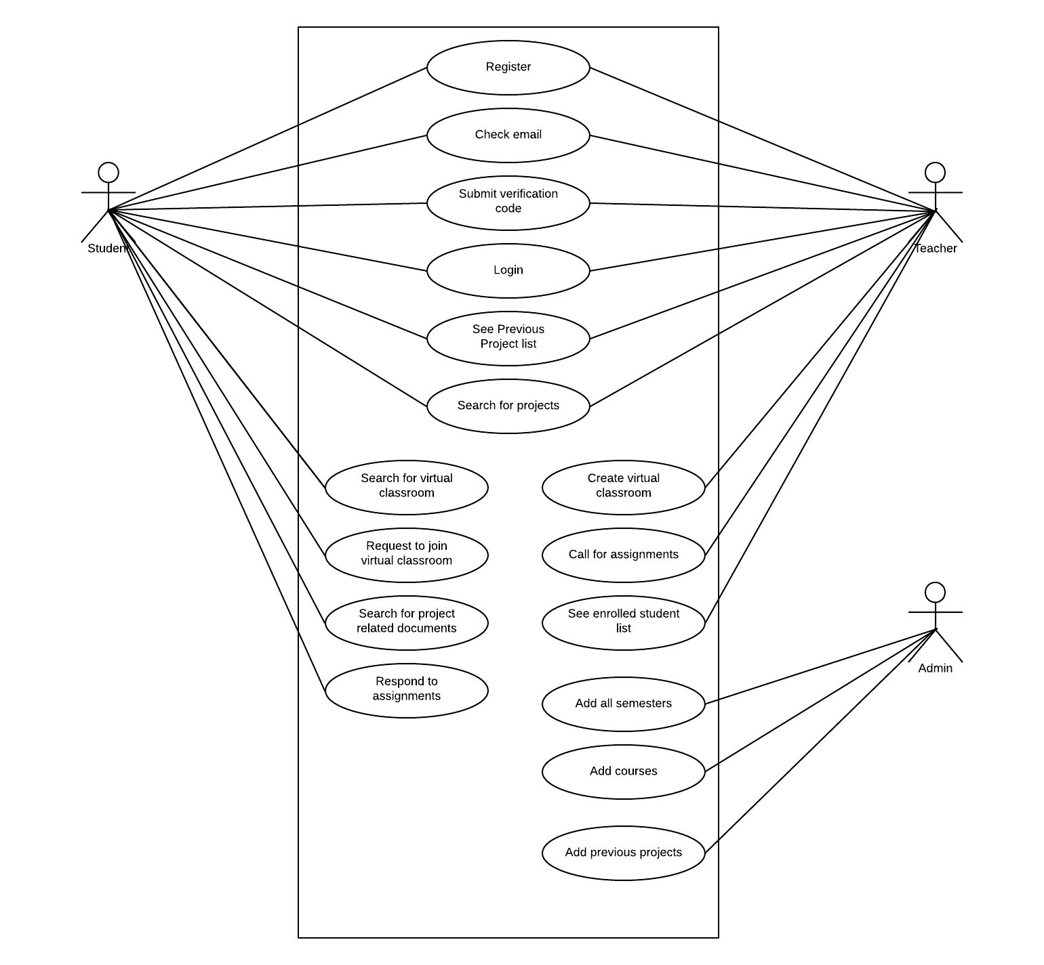

**Figure 3: Use Case Diagram**

© 2019 Daffodil International University 12

**3.2. Use Case Description**

**3.2.1. Register**

Students or teachers have to register to use the application. After registration a verification code will be sent to email of the students or teachers.

|  |  |  |
| --- | --- | --- |
|  |  | **Table 17: Register** |
|  |  | |
| Use Case Name: | Register | |
|  |  | |
| Scenario : | To use the application the user must register first. | |
|  |  | |
| Brief Description: | Students or teacher have to register first. Then they will be able to | |
|  | use the application after logging in to the system. | |
|  |  | |
|  |  | |
| Actor: | Student, Teacher | |
|  |  | |
| Precondition: | User have to have the application installed in his/her device. | |
|  |  | |
|  |  | |
| Post condition: | Users must use the verification code to login that was sent through email. | |
|  |  |  |

**3.2.2. Check email**

Students have to check email for verification code which will be used to verify the registered account.

|  |  |  |
| --- | --- | --- |
|  |  | **Table 18: Check email** |
|  |  | |
| Use Case Name: | Check email | |
|  |  | |
| Scenario : | After registration this phase will be needed to verify account | |
|  |  | |
| Brief Description: | A verification code will be sent to the email which was given | |
|  | While registering to the account that will be used to verify account | |
|  |  | |
|  |  | |
| Actor: | Student, Teacher | |
|  |  | |
| Precondition: | Users have to sign up | |
|  |  | |
|  |  | |
| Post condition: | Users have to use the verification code to verify | |
|  |  |  |

© 2019 Daffodil International University 13

**3.2.3. Submit verification code**

Students or teacher have to submit the verification code which will be sent to the email that was given while registration.

|  |  |  |
| --- | --- | --- |
|  |  | **Table 19: Submit verification code** |
|  |  | |
| Use Case Name: | Submit verification code | |
|  |  | |
| Scenario : | User have to submit verification code that was sent to the email | |
|  |  | |
| Brief Description: | A verification code will be sent to the registered email. User have | |
|  | to use the verification code to verify the account. | |
|  |  | |
|  |  | |
| Actor: | Student, Teacher | |
|  |  | |
| Precondition: | User have to sign up | |
|  |  | |
|  |  | |
| Post condition: | Submitting the verification code accurately. | |
|  |  |  |

**3.2.4. Login**

Students have to login to the application by providing email and password.

|  |  |  |
| --- | --- | --- |
|  |  | **Table 20: Login** |
|  |  | |
| Use Case Name: | Login | |
|  |  | |
| Scenario : | Students or teachers have to login to enter into the application | |
|  |  | |
| Brief Description: | After signing up and verify through verification code users need | |
|  | To login to enter into the application | |
|  |  | |
|  |  | |
| Actor: | Student, Teacher | |
|  |  | |
| Precondition: | Users have to sign up and verify his or her account | |
|  |  | |
|  |  | |
| Post condition: | Users have to keep the login credentials secret. | |
|  |  |  |

© 2019 Daffodil International University 14

**3.2.5. See previous project list**

Students or teachers will be able to see previous project list by clicking previous project list button.

|  |  |  |
| --- | --- | --- |
|  |  | **Table 21: See previous project list** |
|  |  | |
| Use Case Name: | See previous project list | |
|  |  | |
| Scenario : | Students or teachers can see previous project list when they want | |
|  |  | |
| Brief Description: | If a users wants to see previously completed Project list then | |
|  | they can click on the project list button and see the list. | |
|  |  | |
|  |  | |
| Actor: | Student, Teacher | |
|  |  | |
| Precondition: | Users have to login to the application | |
|  |  | |
|  |  | |
| Post condition: | Users can see only the project name, description, student name | |
|  |  |  |

**3.2.6. Search for projects**

Students will be able to search for previous projects. They can search projects by name or by programming languages or by alphabets. By searching for previous projects they will find the information about previous projects.

|  |  |  |
| --- | --- | --- |
|  |  | **Table 22: Search for projects** |
|  |  | |
| Use Case Name: | Search for projects | |
|  |  | |
| Scenario : | Students can search for previous projects. | |
|  |  | |
| Brief Description: | Students will be able to search for previous projects. They can | |
|  | search projects by name or by programming languages or by | |
|  | Alphabets. | |
|  |  | |
| Actor: | Student, Teacher | |
|  |  | |
| Precondition: | Users have to login to the application | |
|  |  | |
|  |  | |
| Post condition: | Users can see only the project name and language used | |
|  |  |  |

© 2019 Daffodil International University 15

**3.2.7. Create virtual classroom**

Teachers will create virtual classroom to manage the project or thesis related courses efficiently.

|  |  |
| --- | --- |
|  | **Table 23: Create virtual classroom** |
|  |  |
| Use Case Name: | Create virtual classroom |
|  |  |
| Scenario : | After selecting course, semester, section teachers will create VC |
|  |  |
| Brief Description: | Virtual classroom will be created to manage the project or |
|  | thesis related courses efficiently. They will provide project or  thesis related documents here |
|  |  |
| Actor: | Teacher |
|  |  |
| Precondition: | Teacher have to be logged in |
|  |  |
| Post condition: | Teachers have to approve student request to join virtual classroom |
|  |  |

**3.2.8. Search for virtual classroom**

Students will search for virtual classroom by providing relevant course, semester, section.

|  |  |
| --- | --- |
|  | **Table 24: Search for virtual classroom** |
|  |  |
| Use Case Name: | Search for virtual classroom |
|  |  |
| Scenario : | Students will search for virtual classroom and will join the required |
|  | classroom which is found after searching |
| Brief Description: | Student will search for virtual classroom where they can join and |
|  | find the project related documents and assignments |
|  |  |
| Actor: | Students |
|  |  |
| Precondition: | Students have to be logged in |
|  |  |
| Post condition: | Students have to wait for approval to join the classroom |
|  |  |

© 2019 Daffodil International University 16

**3.2.9. Request to join virtual classroom**

Student will request to join for virtual classroom after finding the required searched virtual classroom.

|  |  |
| --- | --- |
|  | **Table 25: Request to join virtual classroom** |
|  |  |
| Use Case Name: | Request to join virtual classroom |
|  |  |
| Scenario : | After finding the searched virtual classroom student will request to |
|  | join the classroom |
| Brief Description: | Student must request to join for virtual classroom after finding the |
|  | required searched virtual classroom and wait for the approval |
|  |  |
| Actor: | Students |
|  |  |
| Precondition: | Students have to be logged in |
|  |  |
| Post condition: | Students have to wait for approval to join the classroom |
|  |  |

**3.2.10. Call for assignments**

Teacher will call for project or thesis related assignments in the virtual classroom.

|  |  |
| --- | --- |
|  | **Table 26: Call for assignments** |
|  |  |
| Use Case Name: | Call for assignments |
|  |  |
| Scenario : | When the teachers want to call any assignments, teachers can call it |
|  | in the virtual classroom |
| Brief Description: | Project or thesis related assignments will be called by teachers |
|  | whenever they wants to call it . |
|  |  |
| Actor: | Teacher |
|  |  |
| Precondition: | Teacher have to be logged in to the application |
|  |  |
| Post condition: | The time limit should be given to the students to submit assignment |
|  |  |

© 2019 Daffodil International University 17

**3.2.11. See enrolled student list**

Teachers will be able to see the enrolled student list by clicking see student list button.

|  |  |
| --- | --- |
|  | **Table 27: See enrolled student list** |
|  |  |
| Use Case Name: | See enrolled student list |
|  |  |
| Scenario : | Teachers will be able to see the enrolled student list |
|  |  |
| Brief Description: | When the teacher will click on the see student list button then |
|  | the teacher can see the enrolled student list |
|  |  |
| Actor: | Teacher |
|  |  |
| Precondition: | Teacher have to be logged in to the application |
|  |  |
| Post condition: | Teacher cannot add or delete students from students from list |
|  |  |

**3.2.12. Respond to assignments**

Students will respond to the assignments which was called by teacher

|  |  |
| --- | --- |
|  | **Table 28: Respond to assignments** |

|  |  |
| --- | --- |
|  |  |
| Use Case Name: | Respond to assignments |
|  |  |
| Scenario : | Students will submit the assignments given by teacher |
|  |  |
| Brief Description: | The assignments which were called by teachers will be submitted |
|  | by the students in provided time |
|  |  |
| Actor: | Students |
|  |  |
| Precondition: | Students have to be logged in to the application |
|  |  |
| Post condition: | Students cannot submit assignments after given time |
|  |  |

© 2019 Daffodil International University 18

**3.2.13. Search for project related documents**

Students will be able to search for previously completed project related documents.

|  |  |
| --- | --- |
|  | **Table 29: Search for project related documents** |
|  |  |
| Use Case Name: | Search for project related documents |
|  |  |
| Scenario : | When the students will want to have any project related |
|  | documents, then they can search for that |
| Brief Description: | By clicking on the listed project student will find the project or |
|  | thesis related documents |
|  |  |
| Actor: | Students |
|  |  |
| Precondition: | Students have to be logged in to the application |
|  |  |
| Post condition: | Students cannot add or modify those documents |
|  |  |

**3.2.14. Add semesters**

Admin will add all of the semesters info in the server.

|  |  |
| --- | --- |
|  | **Table 30: Add semesters** |

|  |  |
| --- | --- |
|  |  |
| Use Case Name: | Add semesters |
|  |  |
| Scenario : | To provide all semesters info to teachers or to students admin will |
|  | add all the semester info |
| Brief Description: | All of the semesters info will be added by admin to help students |
|  | and teachers to get the semester info |
|  |  |
| Actor: | Admin |
|  |  |
| Precondition: | Admin must have the access of server |
|  |  |
| Post condition: | Admin cannot have access to enter into the system as teacher or |
|  | students |

© 2019 Daffodil International University 19

**3.2.15. Add courses**

Admin will add all of the courses info in the server.

|  |  |
| --- | --- |
|  | **Table 31: Add courses** |

|  |  |
| --- | --- |
|  |  |
| Use Case Name: | Add courses |
|  |  |
| Scenario : | To provide all courses info to teachers or to students admin will |
|  | add all the courses info |
| Brief Description: | All of the courses info will be added by admin to help students |
|  | and teachers to get the courses info |
|  |  |
| Actor: | Admin |
|  |  |
| Precondition: | Admin must have the access of server |
|  |  |
| Post condition: | Admin cannot have access to enter into the system as teacher or |
|  | students |

**3.2.16. Add previous project list**

Admin will add all of the previous project list info in the server.

|  |  |
| --- | --- |
|  | **Table 32: Add previous project list** |

|  |  |
| --- | --- |
|  |  |
| Use Case Name: | Add previous project list |
|  |  |
| Scenario : | To provide previous project list info to teachers or to students |
|  | admin will add the previous project list |
| Brief Description: | The previous project info list will be added by admin |
|  | to help students and teachers to get the previous project list |
|  |  |
| Actor: | Admin |
|  |  |
| Precondition: | Admin must have the access of server |
|  |  |
| Post condition: | Admin cannot have access to enter into the system as teacher or |
|  | students |

© 2019 Daffodil International University 20

**3.3. Activity Diagram**

**3.3.1. Activity Diagram for Students**

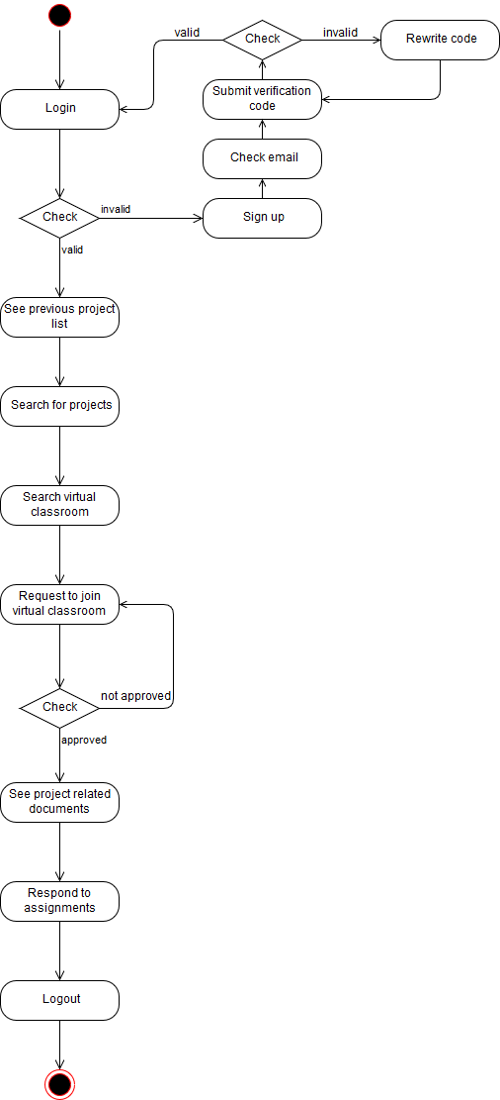

**Figure 4: Activity for students**

© 2019 Daffodil International University 21

**3.3.2. Activity for Teachers**

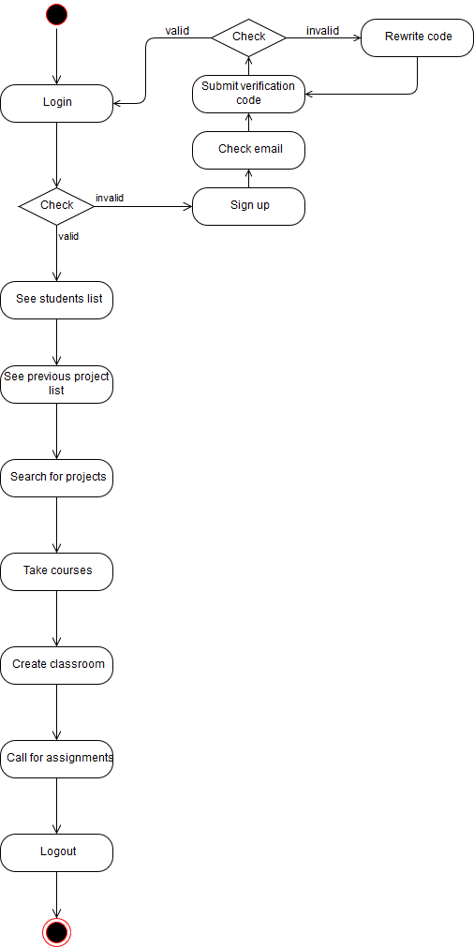

**Figure 5: Activity diagram for teachers**

© 2019 Daffodil International University 22

**3.3.3. Activity for Admin**

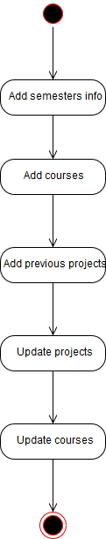

**Figure 6: Activity for admin**

© 2019 Daffodil International University 23

**Chapter IV**

**System Design Specification**

**4.1 Sequence Diagram**

**4.1.1. Sequence diagram for students**

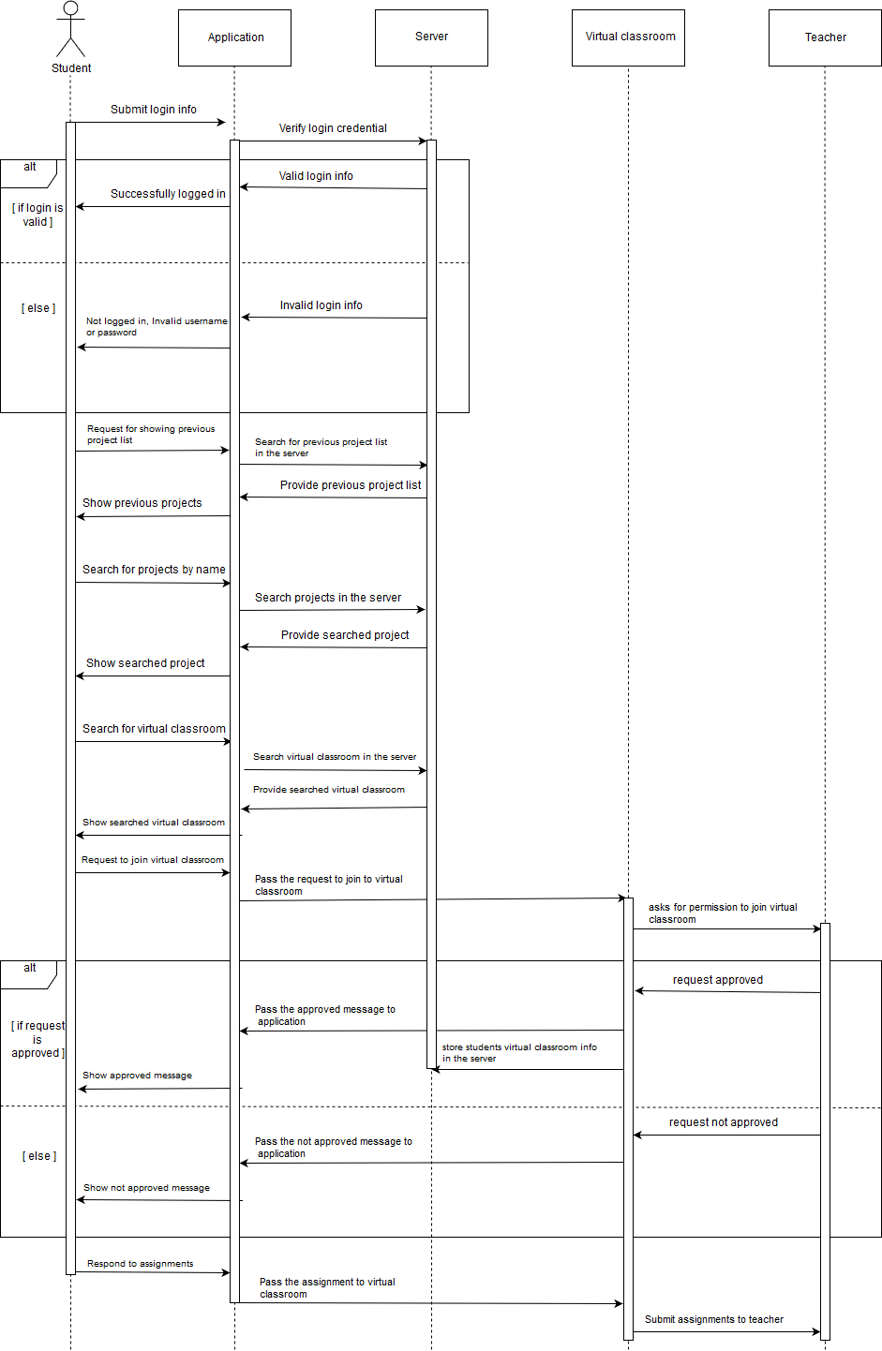

**Figure 7: Sequence 1**

© 2019 Daffodil International University 24

**4.1.2. Sequence diagram for teacher**

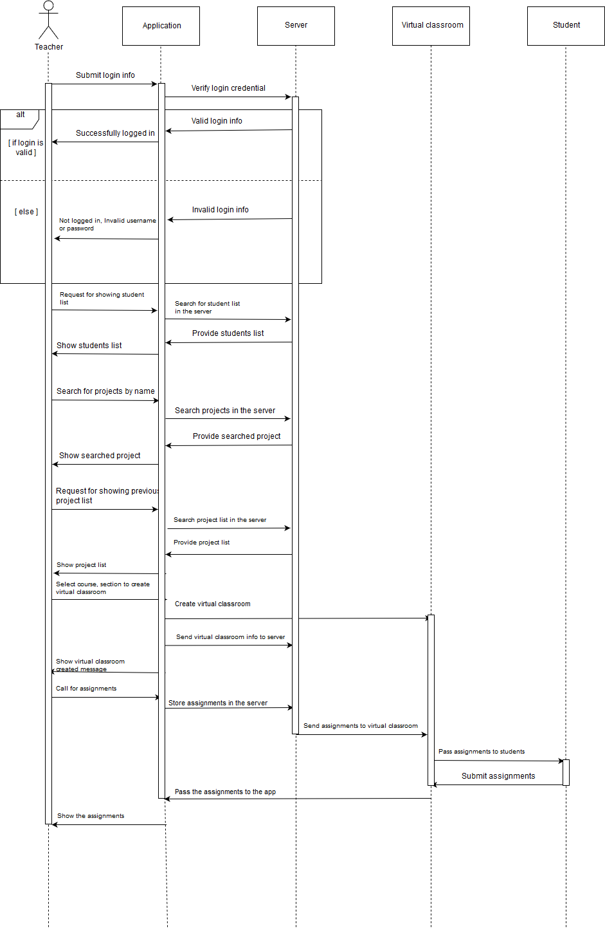

**Figure 8: Sequence 2**

© 2019 Daffodil International University 25

**4.1.3. Sequence diagram for admin**

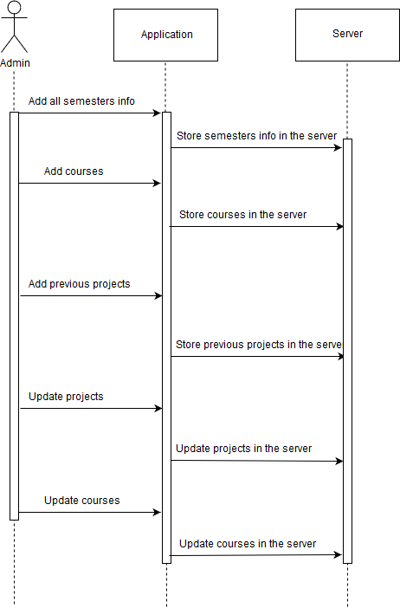

**Figure 9: Sequence 3**

© 2019 Daffodil International University 26

**4.2. Dataflow Diagram**

**4.2.1. DFD Level-0**

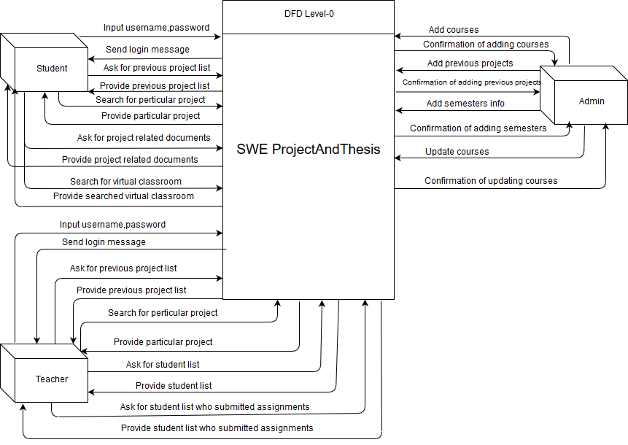

**Figure 10: DFD Level-0**

© 2019 Daffodil International University 27

**4.2.2. DFD Level-1**

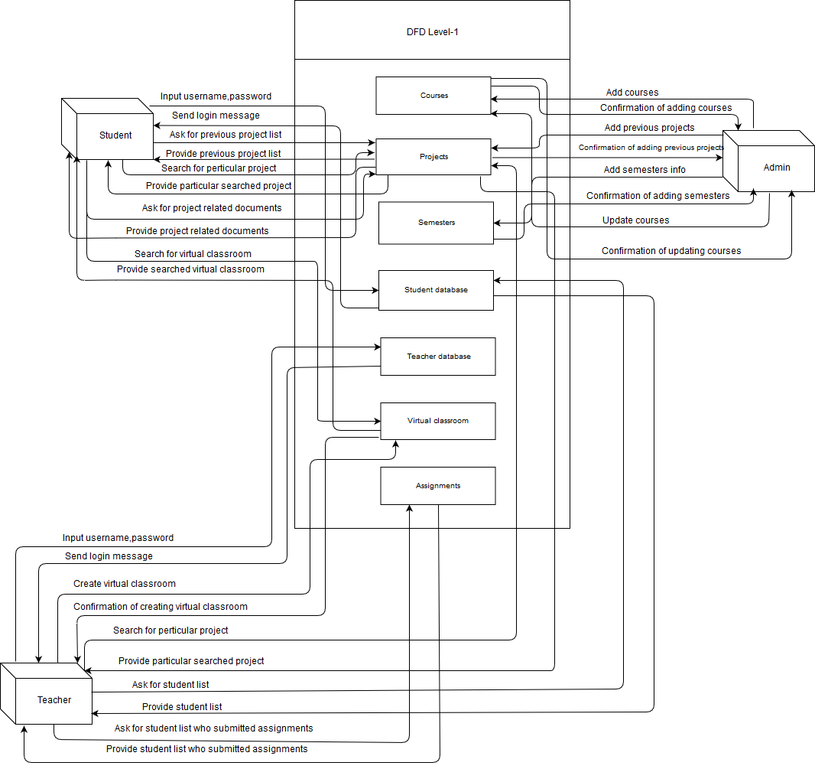

**Figure 11: DFD Level-1**

© 2019 Daffodil International University 28

**4.3. ERD Diagram**

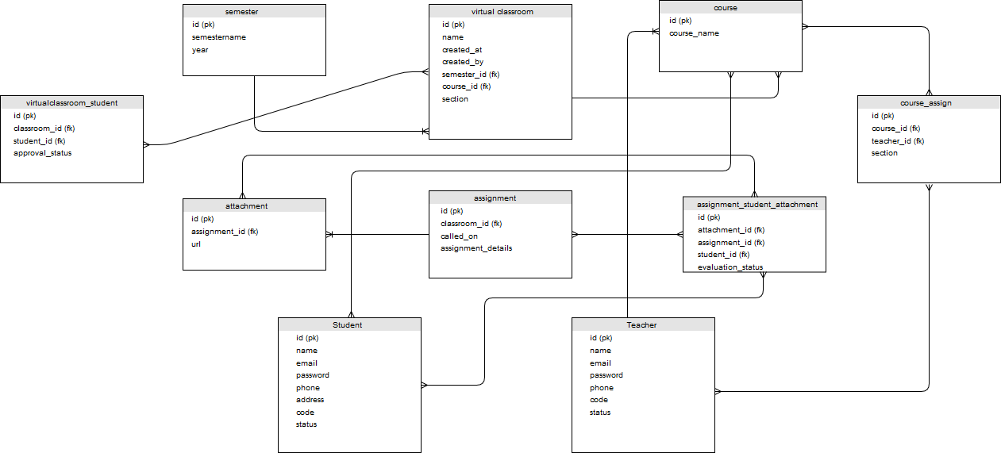

**Figure 12: ERD**

© 2019 Daffodil International University 29

**Chapter V**

**User Interface and Manuals**

5.1. **User Interface**

**5.1.1. Login**

Student or teachers will provide email and password, then they will click the sign in button. If the credentials are valid students or teachers will be logged in.

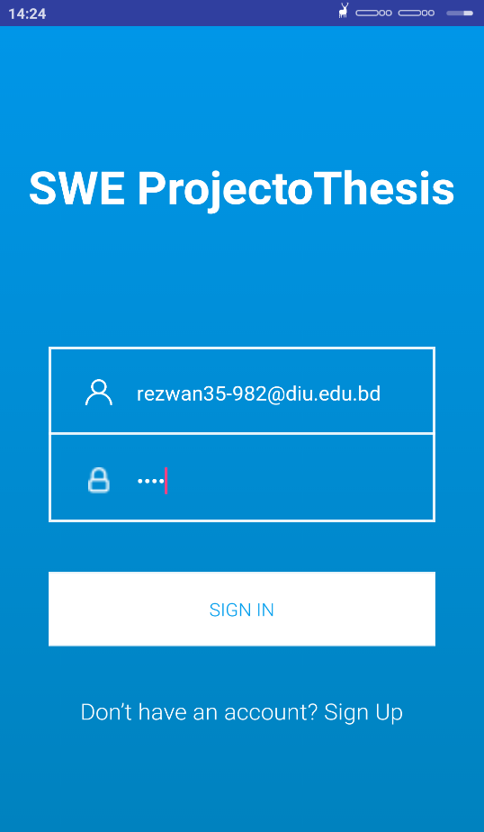

**Figure 13: Login**

© 2019 Daffodil International University 30

**5.1.2. Register Type**

Students or teachers have to register type before Signing in to the application. Users have to select student to register as a student and if the user want to register as a teacher he or she will click on the teacher button to register as teacher.



**Figure 14: Register type**

© 2019 Daffodil International University 31

**5.1.3. Student register**

Students have to provide all of the info to register into the application, After submitting all info student will click on the signup button to register.

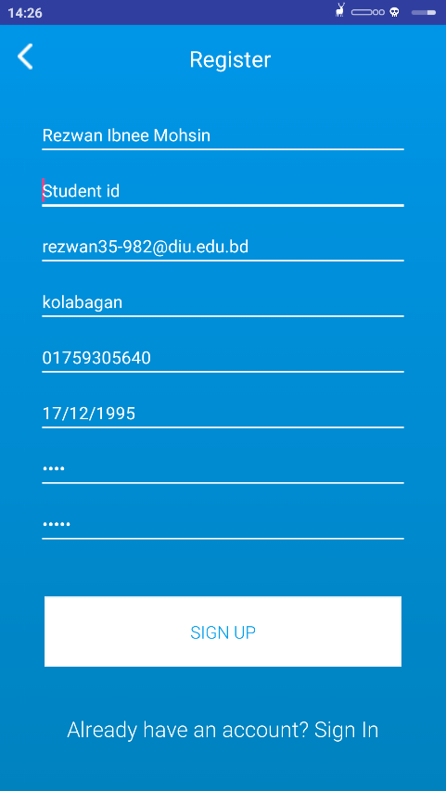

**Figure 15: Student Register**

© 2019 Daffodil International University 32

**5.1.4. Teacher register**

Teachers have to provide all of the info to register into the application, After submitting all info teacher will click on the signup button to register.

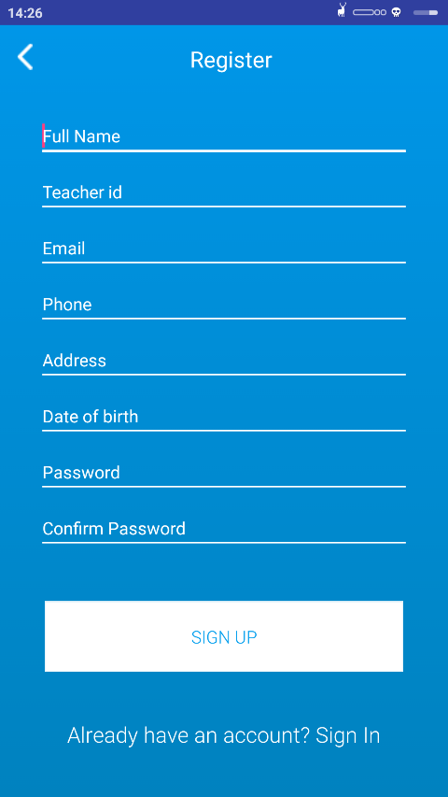

**Figure 16: Teacher Register**

© 2019 Daffodil International University 33

**5.1.5. Take courses**

Teachers will select the semester and the course, after that he or she have to click to save button.

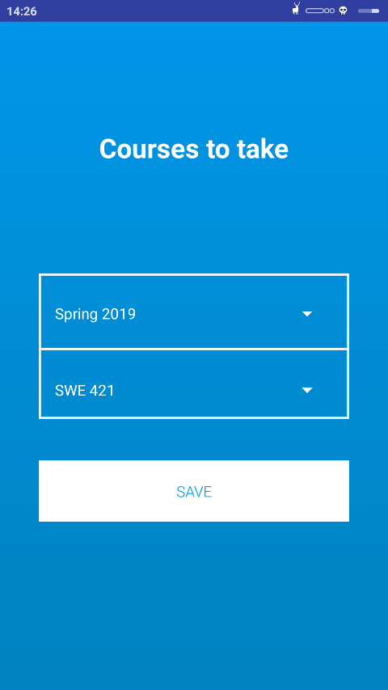

**Figure 17: Take courses**

© 2019 Daffodil International University 34

**5.1.6. Project list**

Students or teachers can the available project list after logging into the system

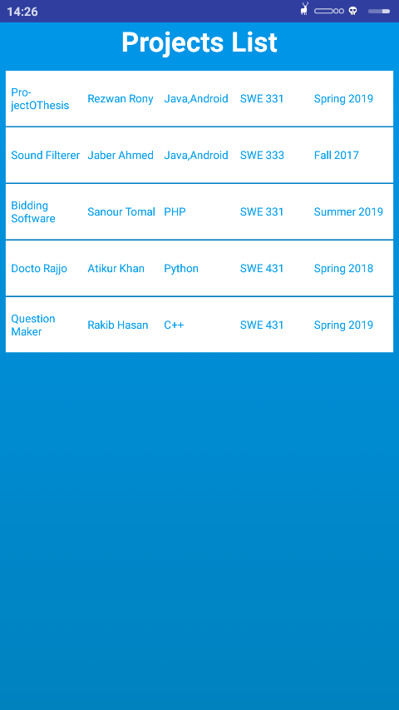

**Figure 18: Project list**

© 2019 Daffodil International University 35

**5.1.7. Project stats**

Students or teachers can see the stats and graph of the previously completed project or thesis based on the programming language used.

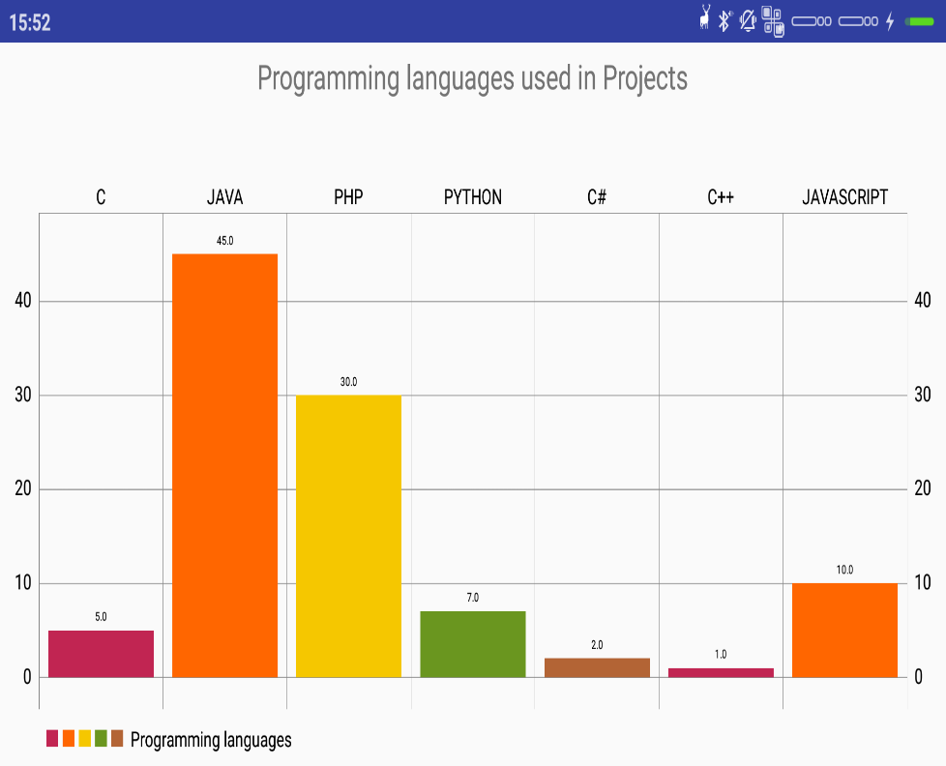

**Figure 19: Project stats**

© 2019 Daffodil International University 36

**Chapter VI**

**Development Tools & Technologies**

**6.1. User Interface Technologies**

* XML

**6.2. Implementation Technologies**

* JAVA
* PHP (Used for API development)
* MYSQL database

© 2019 Daffodil International University 37

**6.3. Platform & Environment**

**6.3.1. Hardware**

* Processor: Intel Core i3.
* RAM: 4GB.
* Hard drive: 1TB.
* Windows 10

**6.3.2. Tools**

* IDE/Editor: Android studio, Sublime Text3

**6.3.3. Version Control**

* Git
* Github (a web based version control hosting for software project)

© 2019 Daffodil International University 38

**Chapter VII**

**System Testing**

**7.1. Introduction**

System testing is done to identify errors. The main objective of system testing are to ensure that the actual process done by the application is correct ad meets the requirements. By doing system testing the errors can be detected efficiently.

**7.2. Test Plan Strategy**

Test plan strategies are really important. The significance of the test plan strategies is to show how the application will be tested and also gives the steps to be followed during the test plans. At first the data is identified and then tested thoroughly.

**7.3. Test Case**

Test cases are set of conditions in which a tester will determine whether an application under the requirements works properly or not. The process of developing test cases can identify problems in the requirements or design of an application.

© 2019 Daffodil International University 39

**7.3.1. Test case of student login**

|  |  |
| --- | --- |
| Test Case #01 | Test Case Name: Testing the student login phase |
|  |  |
| System: SWE ProjectAndThesis | Subsystem: Login |
|  |  |
| Designed By: Rezwan Ibnee Mohsin | Design date: 03.01.19 |
|  |  |
| Executed By: Rezwan Ibnee Mohsin | Execute Date:03.01.19 |
|  |  |

Short Description: This field will test the login functionality of the application.

Precondition: Installing the application

**Table 33: Test case of student login**

|  |  |  |  |  |
| --- | --- | --- | --- | --- |
| Steps | Action | Action Result | Expected System Response | Pass/Fail |
|  |  |  |  |  |
| 01 | Submit valid email and | Get logged in. | Logged in into the system. | Pass |
|  | valid password |  |  |  |
|  |  |  |  |  |
| 02 | Submit valid email and | Not logged in | Not logged in and error | Fail |
|  | invalid password | and error | message. |  |
|  |  | message. |  |  |
|  |  |  |  |  |
| 03 | Click login button | Required | Required message | Fail |
|  | without any data | message |  |  |
|  |  |  |  |  |

**7.3.2. Test case of teacher login**

|  |  |
| --- | --- |
| Test Case #02 | Test Case Name: Testing the teacher login phase |
|  |  |
| System: SWE ProjectAndThesis | Subsystem: Login |
|  |  |
| Designed By: Rezwan Ibnee Mohsin | Design date: 05.01.19 |
|  |  |
| Executed By: Rezwan Ibnee Mohsin | Execute Date:05.01.19 |
|  |  |

Short Description: This field will test the login functionality of the application.

Precondition: Installing the application

© 2019 Daffodil International University 40

**Table 34: Test case of teacher login**

|  |  |  |  |  |
| --- | --- | --- | --- | --- |
| Steps | Action | Action Result | Expected System Response | Pass/Fail |
|  |  |  |  |  |
| 01 | Submit valid email and | Get logged in. | Logged in into the system. | Pass |
|  | valid password |  |  |  |
|  |  |  |  |  |
| 02 | Submit valid email and | Not logged in | Not logged in and error | Fail |
|  | invalid password | and error | message. |  |
|  |  | message. |  |  |
|  |  |  |  |  |
| 03 | Click login button | Required | Required message | Fail |
|  | without any data | message |  |  |
|  |  |  |  |  |

**7.3.3. Test case of student sign up**

|  |  |
| --- | --- |
| Test Case #03 | Test Case Name: Testing the student signup phase |
|  |  |
| System: SWE ProjectAndThesis | Subsystem: Sign up |
|  |  |
| Designed By: Rezwan Ibnee Mohsin | Design date: 07.01.2019 |
|  |  |
| Executed By: Rezwan Ibnee Mohsin | Execute Date:07.01.2019 |
|  |  |

Short Description: This field handle's the signup functionality of the application.

Precondition: Installing the application

© 2019 Daffodil International University 41

**Table 35: Test case of student signup**

|  |  |  |  |  |
| --- | --- | --- | --- | --- |
| Steps | Action | Action Result | Expected System Response | Pass/Fail |
|  |  |  |  |  |
| 01 | Click Register without | Required | Required message | Fail |
|  | any data | message |  |  |
|  |  |  |  |  |
| 02 | Click Register after | Not signed up | Not signed up and required | Fail |
|  | filling some data | and required | messages. |  |
|  |  | messages. |  |  |
|  |  |  |  |  |
| 03 | Click Register with valid | Signed up in and | No Required message | Fail |
|  | data and password less | error message. |  |  |
|  | than 6 characters. |  |  |  |
|  |  |  |  |  |
| 04 | Click Register with valid | Not signed up in | Not signed up in and error | Fail |
|  | data and password not | and error | message. |  |
|  | matching with confirm | message. |  |  |
|  | password. |  |  |  |
|  |  |  |  |  |
| 05 | Click Register with valid | Signed up and | Signed up and redirected to | Pass |
|  | data and password. | redirected to | main landing page. |  |
|  |  | main landing |  |  |
|  |  | page. |  |  |
|  |  |  |  |  |

**7.3.4. Test case of teacher sign up**

|  |  |
| --- | --- |
| Test Case #04 | Test Case Name: Testing the teacher signup phase |
|  |  |
| System: SWE ProjectAndThesis | Subsystem: Sign up |
|  |  |
| Designed By: Rezwan Ibnee Mohsin | Design date: 09.01.2019 |
|  |  |
| Executed By: Rezwan Ibnee Mohsin | Execute Date:09.01.2019 |
|  |  |

Short Description: This field handle's the signup functionality of the application.

Precondition: Installing the application

© 2019 Daffodil International University 42

**Table 36: Test case of teacher signup**

|  |  |  |  |  |
| --- | --- | --- | --- | --- |
| Steps | Action | Action Result | Expected System Response | Pass/Fail |
|  |  |  |  |  |
| 01 | Click Register without | Required | Required message | Fail |
|  | any data | message |  |  |
|  |  |  |  |  |
| 02 | Click Register after | Not signed up | Not signed up and required | Fail |
|  | filling some data | and required | messages. |  |
|  |  | messages. |  |  |
|  |  |  |  |  |
| 03 | Click Register with valid | Signed up in and | No Required message | Fail |
|  | data and password less | error message. |  |  |
|  | than 6 characters. |  |  |  |
|  |  |  |  |  |
| 04 | Click Register with valid | Not signed up in | Not signed up in and error | Fail |
|  | data and password not | and error | message. |  |
|  | matching with confirm | message. |  |  |
|  | password. |  |  |  |
|  |  |  |  |  |
| 05 | Click Register with valid | Signed up and | Signed up and redirected to | Pass |
|  | data and password. | redirected to | main landing page. |  |
|  |  | main landing |  |  |
|  |  | page. |  |  |
|  |  |  |  |  |

**7.4. Features yet not tested**

**Table 26: Features yet not tested**

|  |  |  |
| --- | --- | --- |
| No | Name | Users |
|  |  |  |
| 01 | Manage Orders | Admin |
|  |  |  |
| 02 | Manage Category | Admin |
|  |  |  |
| 03 | Barcode code generation | System/ Admin |
|  |  |  |
| 04 | Print order report | System/ Admin |
|  |  |  |

© 2019 Daffodil International University 43

**Chapter VIII**

**Project Summary**

**8.1. GitHub Link**

**https://github.com/rezwanrony/SWEProjectAndThesis**

**8.2. Limitations**

* The application is only for SWE department of DIU.
* The teachers cannot evaluate the assignments of the students.

**8.3. Obstacle & Achievements**

**Obstacle:**

* Learning new technology and environment
* Limited time

**Achievements**

* Learnt new technologies
* Successfully build a full project

**8.4. Conclusion**

The project was developed to help the SWE department to manage the project or thesis related courses. The objective was to help the teachers to maintain the project and thesis related courses and to help the students to find project related documents easily. If the project can help our department single percent then the project will be the one to proud of.

© 2019 Daffodil International University 44

**8.5. Future Work**

The project has some limitation like there is no option to evaluate the student’s submitted assignments. It will be added in future. Maximum security will be ensured in the project further.

© 2019 Daffodil International University 45

**Key of Terms**

**A**

Abstract

Acknowledgement

Approval

Associate Review Analysis

**H**

Hardware and Software Specification Html5

**C**

Conclusion

Class Diagram

Context Diagram

**E**

E-commerce Entity Relationship Diagram

**S**

System description

Software Requirement Specification

Software Development Plan

System Design

System Overview

System Scope

Software Specification

**F**

**I**

Implementation

Introduction

**D**

Definition and abbreviations

Design map

Database Name

**J**

JavaScript

JQuery

Future work

Functional Requirements

**T**

Testing

Test case

Tools

Technical Description

**U**

Use case diagrams

**N**

Non-Functional requirements

© 2019 Daffodil International University 46

**References**

**[1].**Use case diagram tutorial, available:https://www.smartdraw.com/use-case-diagram/.

**[2].**Creating rest api using php, available: https://www.codeofaninja.com/2017/02/create-simple-rest-api-in-php.html

1. Volley with raw json data, available: https://stackoverflow.com/questions/48424033/android-volley-post-request-with-json-object-in-body-and-getting-response-in-str.
2. Parsing json with volley library. available: https://www.thorntech.com/2016/03/parsing-json-android-using-volley-library/.
3. Test cases tutorial, available: https://www.guru99.com/test-case.html
4. DFD and Sequence diagram tutorial, available: https://www.slideshare.net/HamnaShahzad/data-flow-diagram-and-sequence-diagram

© 2019 Daffodil International University 47